Dynamic Timeline Visual User Guide

Setup
To add the visual to your report, first click the Get More Visuals button in the Visualizations panel and select “Import a visual from a file”.
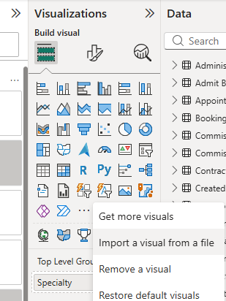
Importing a Power BI Visual
For LUHFT users, the file is located here: \\rlbuht.lan\groups\BITeam\Templates, Images and Icons\Power BI Visuals\
For other users, the visual can be downloaded here: https://github.com/davevickNHS/dynamicTimelineVisual
When you open the file, the visual will appear in the bottom row of the Visualizations panel.
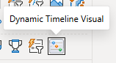
Dynamic Timeline Visual icon

Usage

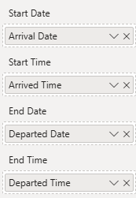
Dates and Times
Start Date (Mandatory) – This is the only mandatory field. This can be a date or datetime value.
Start Time (Optional) – When used, the Start Date and Time values are combined to form the datetime used on the timeline. This field is mainly included to accommodate the use of separate date and time fields in the dimensional models.
End Date (Optional) – When used, the event marker becomes a rectangular time range. When this is omitted, or the value is blank, a diamond point-in-time marker will be used instead. An ongoing event can be specified using a special end date value, ‘01/01/9999’. This is drawn as a time range that runs from the start date up to the current time indicator with a feathered edge,
Date and Time fields
End Time (Optional) – Combines with the End Date in the same way as Start Date/Time. When this field is used and End Date is omitted, the End Time combines with Start Date to form a time range.

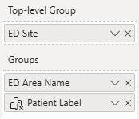
Groups
Groups (Optional) – Splits the timeline into ‘swim lanes’. Adding a second field breaks these down into subgroups.
Top-level Group (Optional) – Adds a drop-down filter above the timeline. When the number of filter options exceeds a user-defined limit (default: 100), a message will be displayed and the timeline will not be rendered. This helps to avoid overloading errors. As an example, this can be used to ensure that a slicer filter has been applied before rendering.
Group fields
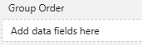
Group Order (Optional) – Numeric field which specifies the order of group rows. When this is omitted, groups will default to an alphabetical sort order. More sort options are available in the options menu in the top-right (highlighted in the image below.)
Group order field
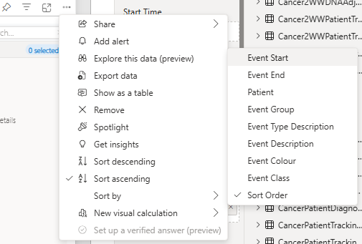
Group sort options

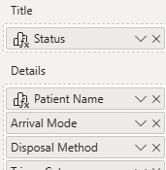
Details
Title (Optional) – Appears in the header of tooltips and Details cards.
Details (Optional) – Accepts an unlimited number of fields. These field values are displayed in tooltips and Details panel. Blank and ‘Not Specified’ field values are not displayed. Field names are shown by default but can be turned off in the Details options panel.
Detail fields

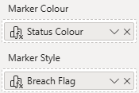
Colours and Styling
Marker Colour (Optional) – Specifies the colour of the event marker in an RGB hex code format (eg. #fffee0). When this field is blank or omitted, colours default to the selected Power BI theme.
Marker Style (Optional) – Applies an additional style to the marker. Styles come in two main types – sashes and flags. Sashes are good for indicating an unusual event (eg. Cancelled appointments.) Flags are good for highlighting the status of an event (eg. Pending or completed assessments.)
Colour and Style fields

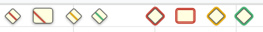
Sash and flag marker styles
This image demonstrates the following styles:
- sash-red (shown as a diamond and rectangular marker)
- sash-amber
- sash-green
- flag-red (shown as a diamond and rectangular marker)
- flag-amber
- flag-green

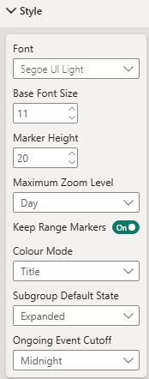
Style Options
Font – The single font is used across all parts of the visual.
Base Font Size – For simplicity, a single base font size is used from which all other font sizes are derived (eg. The x-axis font is 2pt smaller than the base font size.)
Marker Height – Affects the height of the event markers and rows.
Maximum Zoom Level – Dictates how close the user can zoom into the timeline.
Keep Range Markers – When the timeline is zoomed out to the point where a rectangular range marker is less than a few pixels wide, it will revert to a diamond marker. This option disables that functionality.
Colour Mode – When the Marker Colour field is blank or omitted, this setting dictates how colours are allocated. The three modes are:
Style options panel
- Group – markers within a group are all given the same colour
- Title – markers with the same Title value are given the same colour
- Group and Title – colours are allocated using a combination of the two.
Subgroup Default State – Dictates whether subgroups are show or hidden by default. Default is Expanded.
Ongoing Event Cutoff – Ongoing event time ranges can be set to cut off at the current time or at 00:00 on the current day. Midnight usually represents an overnight update cutoff.)

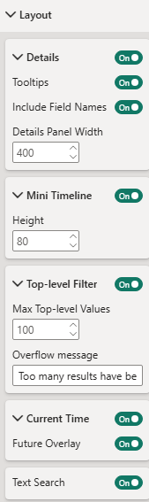
Layout Options
Most elements of the visual can be hidden use the toggle switches in this panel. I’ve explained some of the less obvious options below:
Include Field Names – Indicates whether each detail value should be preceded by the field name.
Details Panel Width – Specifies the width of the right-hand details panel. Default is 300px.
Mini Timeline Height – Specifies the height of the mini timeline that sits below the main timeline. Default is 80px.
Max Top-level Values – Specifies the maximum number of distinct values that are allowed before an overflow message is displayed.
Overflow Message – Contains the message that is displayed when the Max Top-level Values figure is exceeded.
Current Time – This is a red line indicator that shows on each timeline, tracking the current time.
Future Overlay – This is a blue background overlay that sits to the right-hand side of the current time indicator. This makes it clear to users when they are looking at future events.
Layout options panel

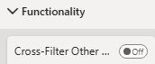
Functionality Options
Cross-Filter Other Visuals – When enabled, selecting a marker causes other visuals on the report page to react by filtering or highlighting their data accordingly.
Functionality options panel

Visual Calculations and Calculation Fields
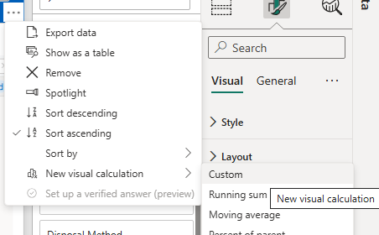
The latest version of Power BI allows for DAX calculations to be added at the visual level. This means that calculated fields can be added to a report without the need for changes to the underlying semantic model.
These can be used to add calculated Marker Colour and Marker Style fields to any report.

Adding Visual Calculations
You can add a visual calculation field from the options menu in the top-right corner of the visual, choosing the ‘Custom’ option. This will open the expression editor panel which consists of a table view of the data fields attached to the visual and a formula bar. The layout of the expression editor is similar to Excel and many of the DAX functions use a syntax similar to Excel formulas.
Adding a new visual calculation field
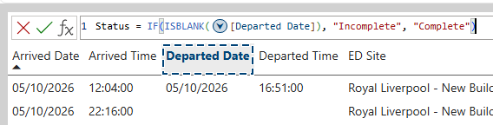
Visual calculation expression editor
The example pictured above shows a new [Status] field being declared based on the contents of the [Departed Date] field. This example can be expanded to specify Marker Colour and Marker Style values:
Status Colour = IF(ISBLANK([Departed Date]), “#FF0000”, “#0000FF”)
Breach Flag = IF([12HourBreachFlag] = 1, “flag-red”, IF([4HourBreachFlag] = 1, “flag-amber”, “”))
Once defined, these fields can be moved into the Marker Colour and Marker Style data sections, like regular fields. Clicking on a visual calculation field will return you to the expression editor.
A more complete explanation of visual calculations and the DAX functions that can be used with them can be found here:
https://learn.microsoft.com/en-us/power-bi/transform-model/desktop-visual-calculations-overview

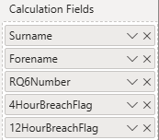
Calculation Fields
For a data field to be used in a visual calculation, it must be included in one of the visual’s data sections. The Calculation Fields section has been set up to house data fields that are needed for use in a DAX expression but do not belong to any other section. In this case, the [4HourBreachFlag] and [12HourBreachFlag] fields have been stored here, allowing them to be referenced in the [Breach Flag] calculation above.
Calculation Fields data section

